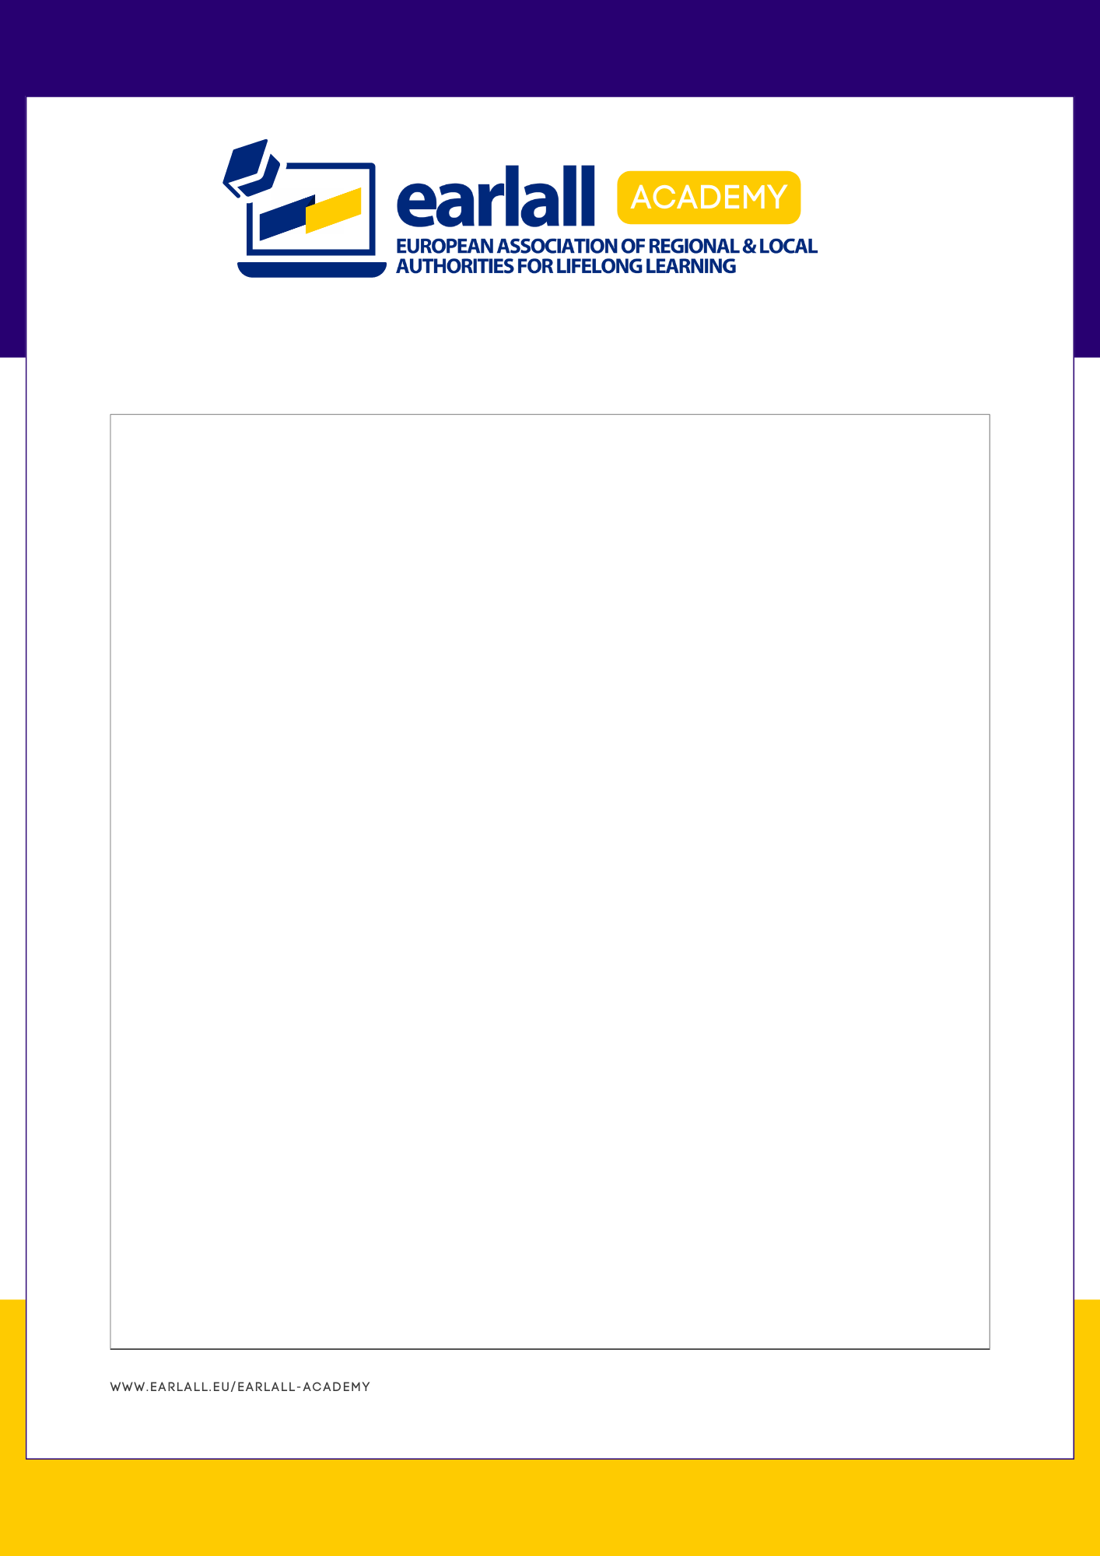

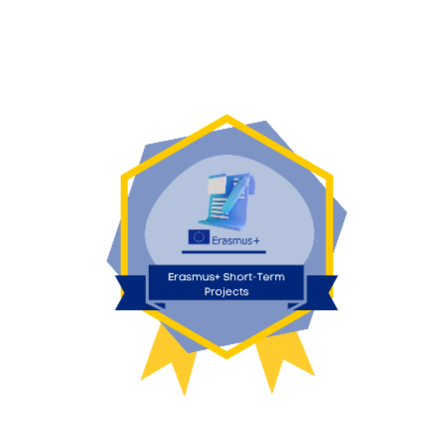

Webinar 5: Organising an accredited Erasmus+ VET Consortium for high quality mobility

Background information
Pernilla Öberg is an experienced Erasmus+ Coordinator and Worked-Based Learning Strategist coordinating one of the largest Erasmus+ VET consortia in Sweden. Having been a former pioneer using ECVET in practice, high quality VET is still her highest and collaboration across borders her motto.

Learning Outcomes:

Key Points

Curious to find out more?

Your questions, answered

